**Assignment 2**

**1. Select from any table a number and determine whether it is within a given range (for**

**example, between 1 and 10).**

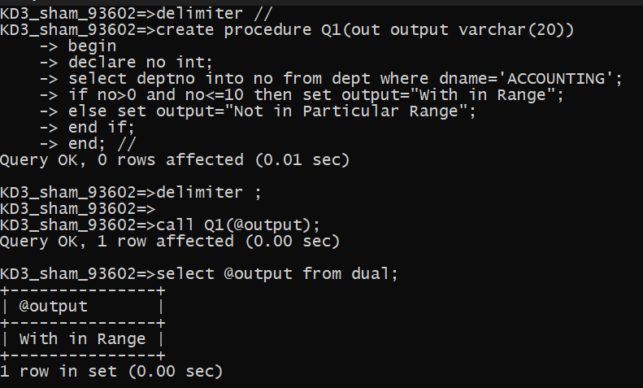

**2. Select from any table three positive integers representing the sides of a triangle, and**

**determine whether they form a valid triangle. Hint: In a triangle, the sum of any two**

**sides must always be greater than the third side.**

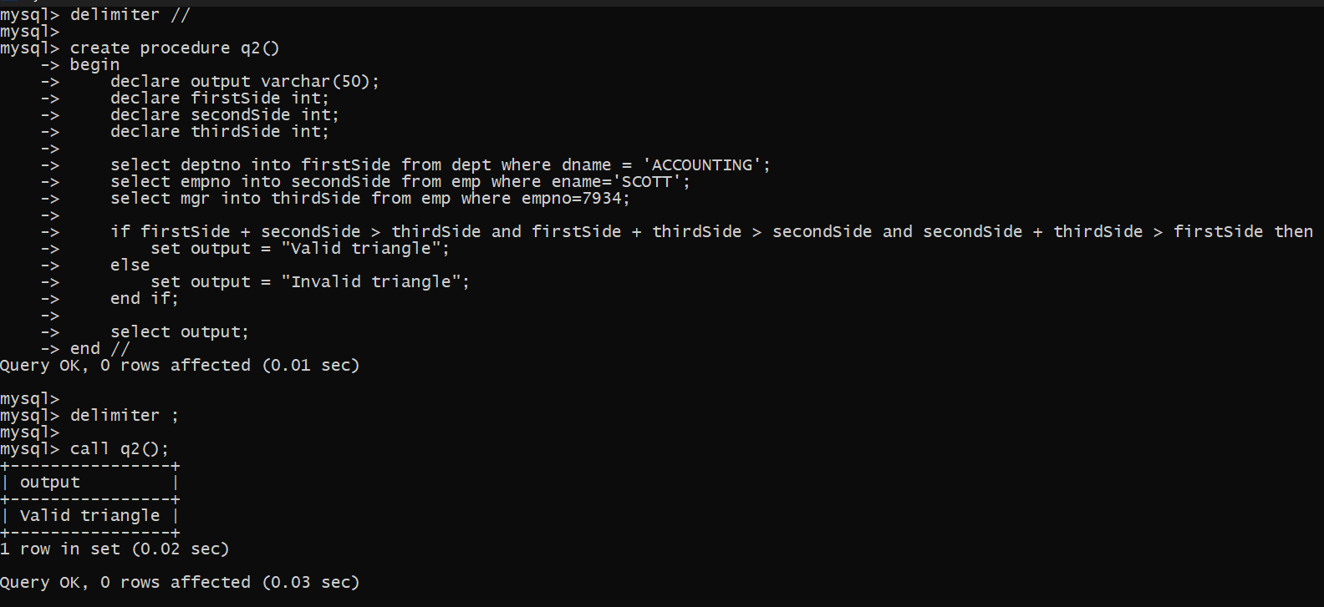

**3. Check if a given a year is a leap year. The condition is:- year should be (divisible by 4**

**and not divisible by 100) or (divisible by 4 and divisible by 400.). The year should be**

**Selected from some table.**

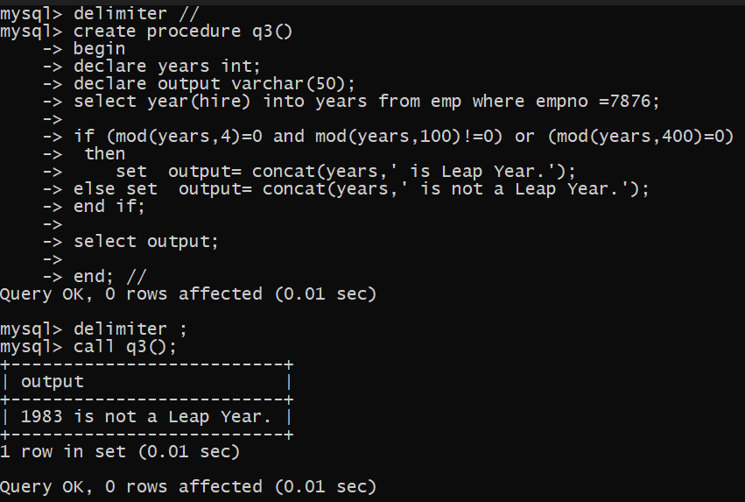

**4. Write a program that Selects from any table two character strings. Your program should**

**then determine if one character string exists inside another character string.**

